Develop Framework for Selenium

1. Install Eclipse IDE (ozone), drivers and browsers as per below specification.

|  |  |
| --- | --- |
| **Maven Dependency** | |
| cucumber-java | 1.2.5 |
| cucumber-junit | 1.2.5 |
| junit | 4.12 |
| selenium-java | 3.4.0 |
| **Browsers** | |
| Firefox | 53.0.3 |
| Internet Explorer | 11.0 |
| Chrome | 65.0.3325.181 |
| **Webdrivers** | |
| Chromedriver | 2.37 |
| GecoDriver (x86) | 0.16.0 |
| IEDriver (x86) | 3.4.0 |

1. Open Eclipse . File->New-> Other
2. Create a Maven Project. Maven🡪Maven Project

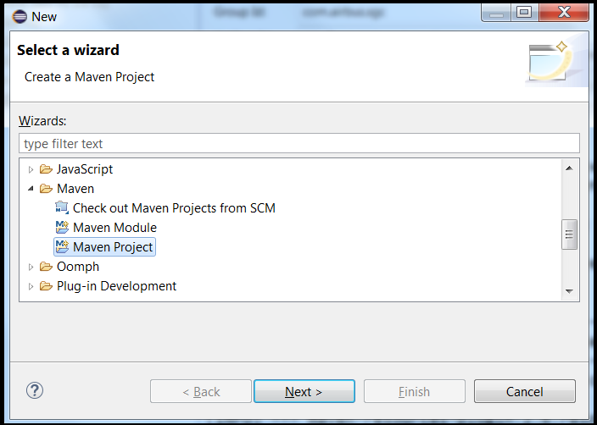

1. Click on Next Button.

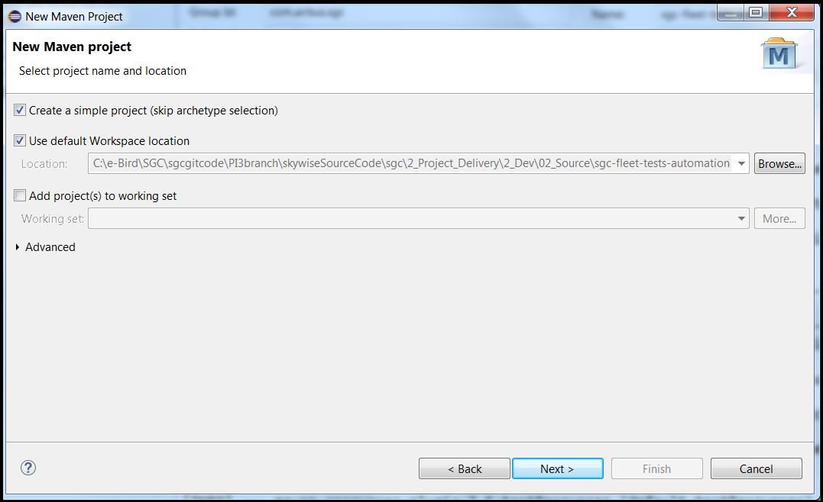

1. Enter Group ID and Artifact ID and click on finish button.

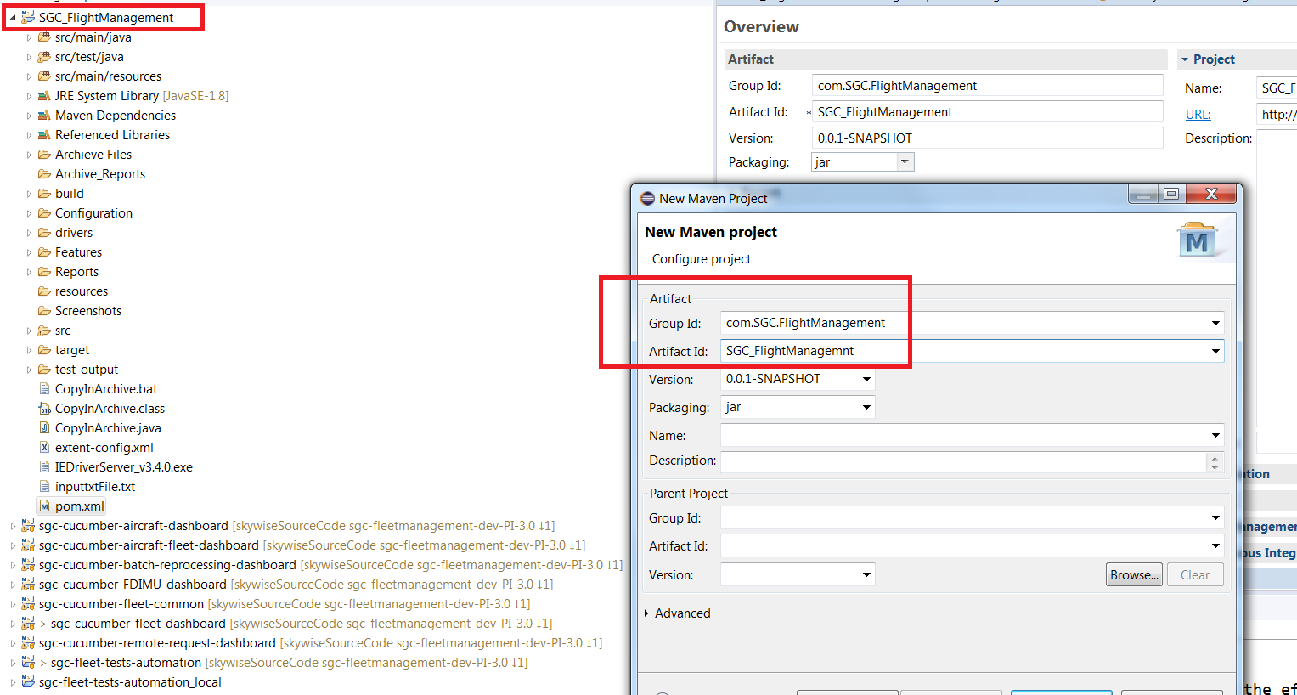

1. Select the project and open the pom.xml

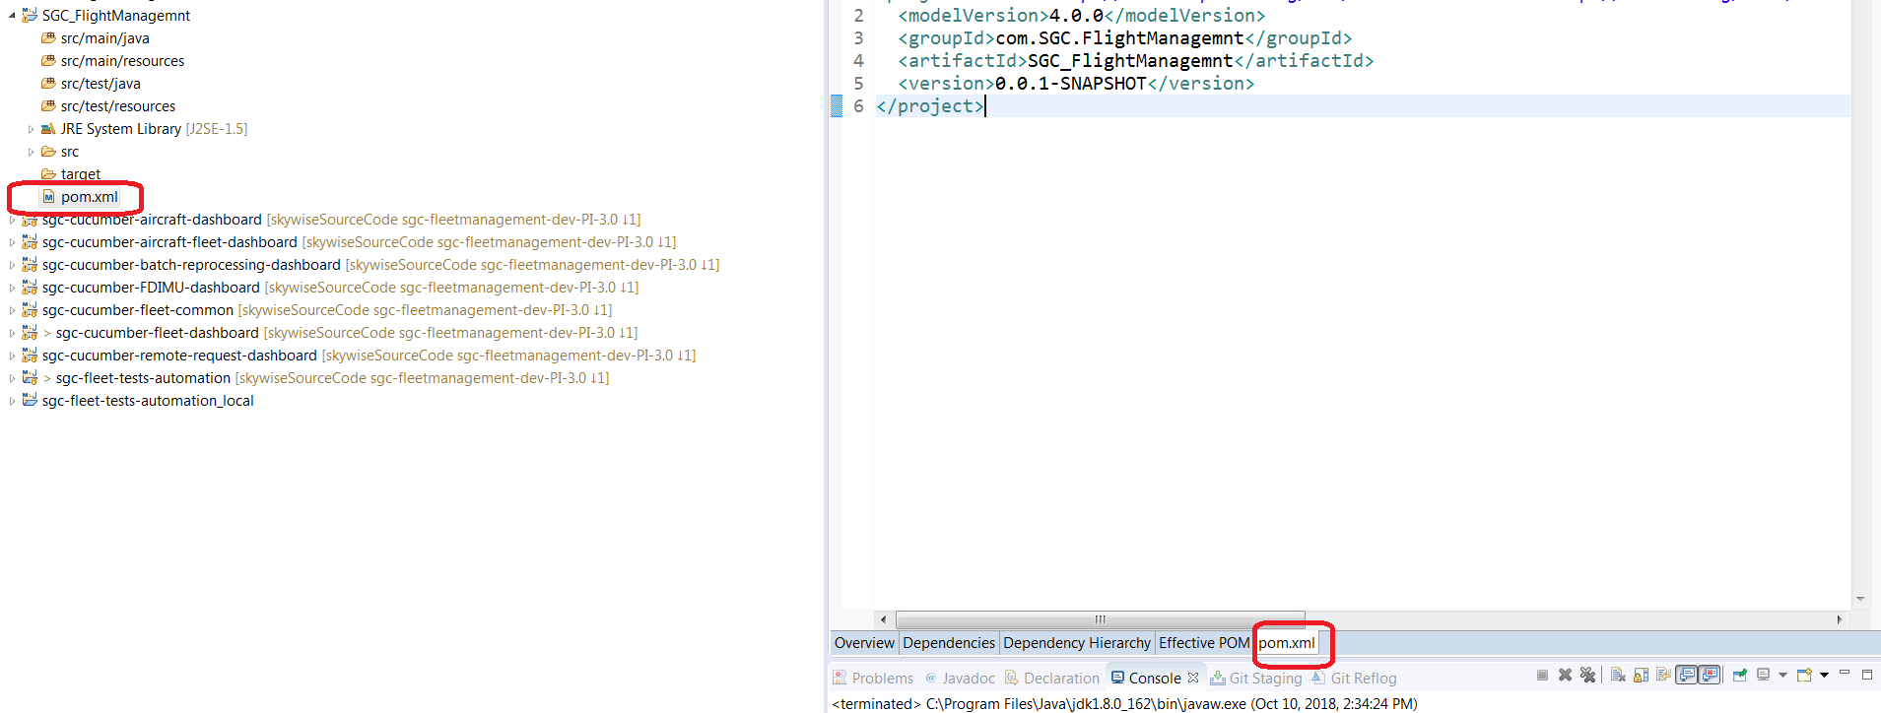

1. Enter the dependency under POM.xml

<dependencies>

**<dependency>**

**<groupId>org.seleniumhq.selenium</groupId>**

**<artifactId>selenium-java</artifactId>**

**<version>3.4.0</version>**

**</dependency>**

<!-- <dependency>

<groupId>org.testng</groupId>

<artifactId>testng</artifactId>

<version>6.9.9</version>

<scope>test</scope>

</dependency> -->

<!-- https://mvnrepository.com/artifact/info.cukes/cucumber-junit -->

<!-- -->

**<dependency>**

**<groupId>info.cukes</groupId>**

**<artifactId>cucumber-junit</artifactId>**

**<version>1.2.5</version>**

**<scope>test</scope>**

**</dependency>**

**<dependency>**

**<groupId>info.cukes</groupId>**

**<artifactId>cucumber-java</artifactId>**

**<version>1.2.5</version>**

**</dependency>**

**<dependency>**

**<groupId>junit</groupId>**

**<artifactId>junit</artifactId>**

**<version>4.12</version>**

**<scope>test</scope>**

</dependency>

<dependency>

<groupId>com.codeborne</groupId>

<artifactId>selenide</artifactId>

<version>2.23</version>

</dependency>

<dependency>

<groupId>org.apache.commons</groupId>

<artifactId>commons-lang3</artifactId>

<version>3.4</version>

</dependency>

<dependency>

<groupId>org.apache.poi</groupId>

<artifactId>poi</artifactId>

<version>3.12</version>

</dependency>

<dependency>

<groupId>org.apache.poi</groupId>

<artifactId>poi-ooxml</artifactId>

<version>3.9</version>

</dependency>

<dependency>

<groupId>xml-apis</groupId>

<artifactId>xml-apis</artifactId>

<version>1.4.01</version>

</dependency>

<!-- https://mvnrepository.com/artifact/com.relevantcodes/extentreports -->

**<dependency>**

**<groupId>com.relevantcodes</groupId>**

**<artifactId>extentreports</artifactId>**

**<version>2.41.2</version>**

**</dependency>**

**<dependency>**

**<groupId>com.vimalselvam</groupId>**

**<artifactId>cucumber-extentsreport</artifactId>**

**<version>3.0.2</version>**

**</dependency>**

**<dependency>**

**<groupId>com.aventstack</groupId>**

**<artifactId>extentreports</artifactId>**

**<version>3.1.3</version>**

**<scope>provided</scope>**

**</dependency>**

</dependencies>

<!-- Code required to run java runner file from pom file -->

<build>

<plugins>

<plugin>

<groupId>org.apache.maven.plugins</groupId>

<artifactId>maven-compiler-plugin</artifactId>

<version>3.7.0</version>

<configuration>

<source>1.8</source>

<target>1.8</target>

<fork>true</fork>

<!-- <executable>C:\Program Files\Java\jdk1.8.0_162\bin\javac</executable> -->

<executable>${env.JAVA_HOME}\bin\javac.exe</executable>

</configuration>

</plugin>

<plugin>

<groupId>org.apache.maven.plugins</groupId>

<artifactId>maven-surefire-plugin</artifactId>

<version>2.21.0</version>

<configuration>

<includes>

<!-- <include>**/Fleet_ActivityManagement_AlreadyLoadedFileStepStatus_RUN2</include> -->

<include>**/ActivityDashboardPreLoadedFileRunner</include>

</includes>

</configuration>

</plugin>

</plugins>

</build>

1. Click on save button.
2. Screenshot of folder structure.

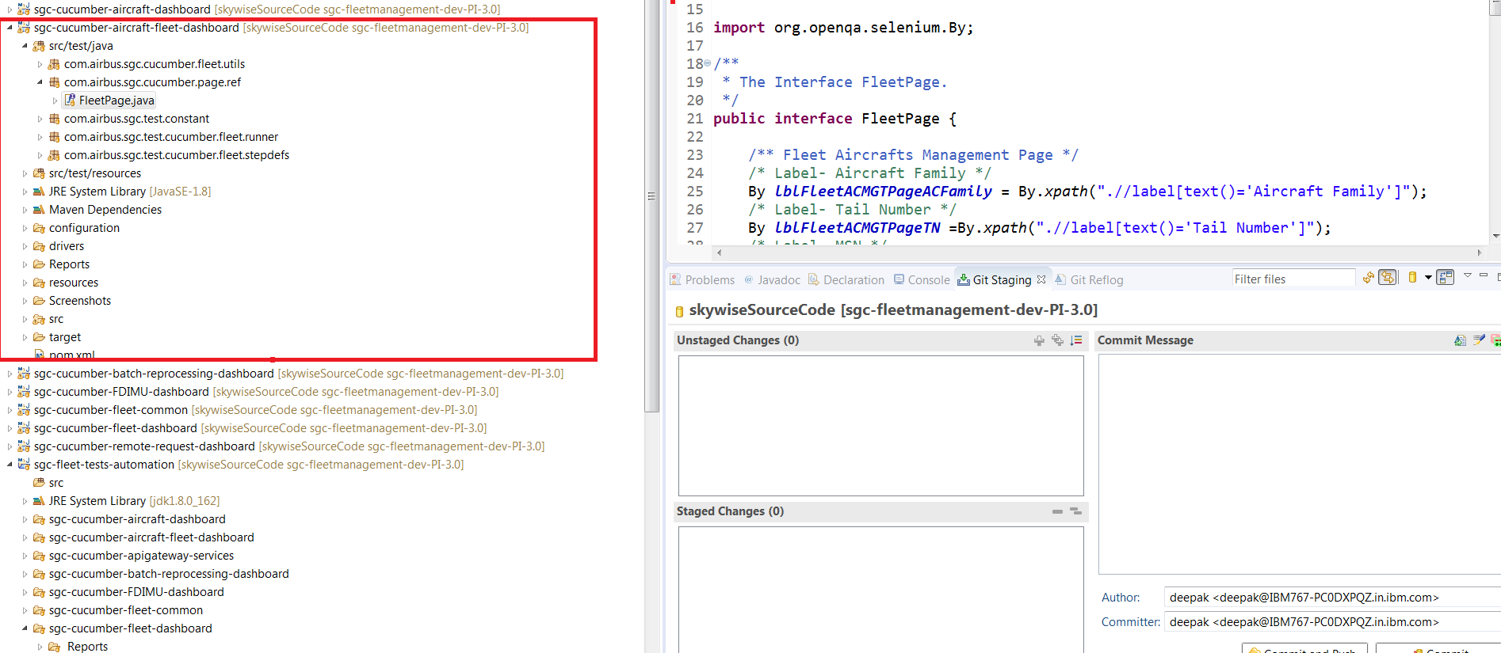

1. Folder Internal Content.

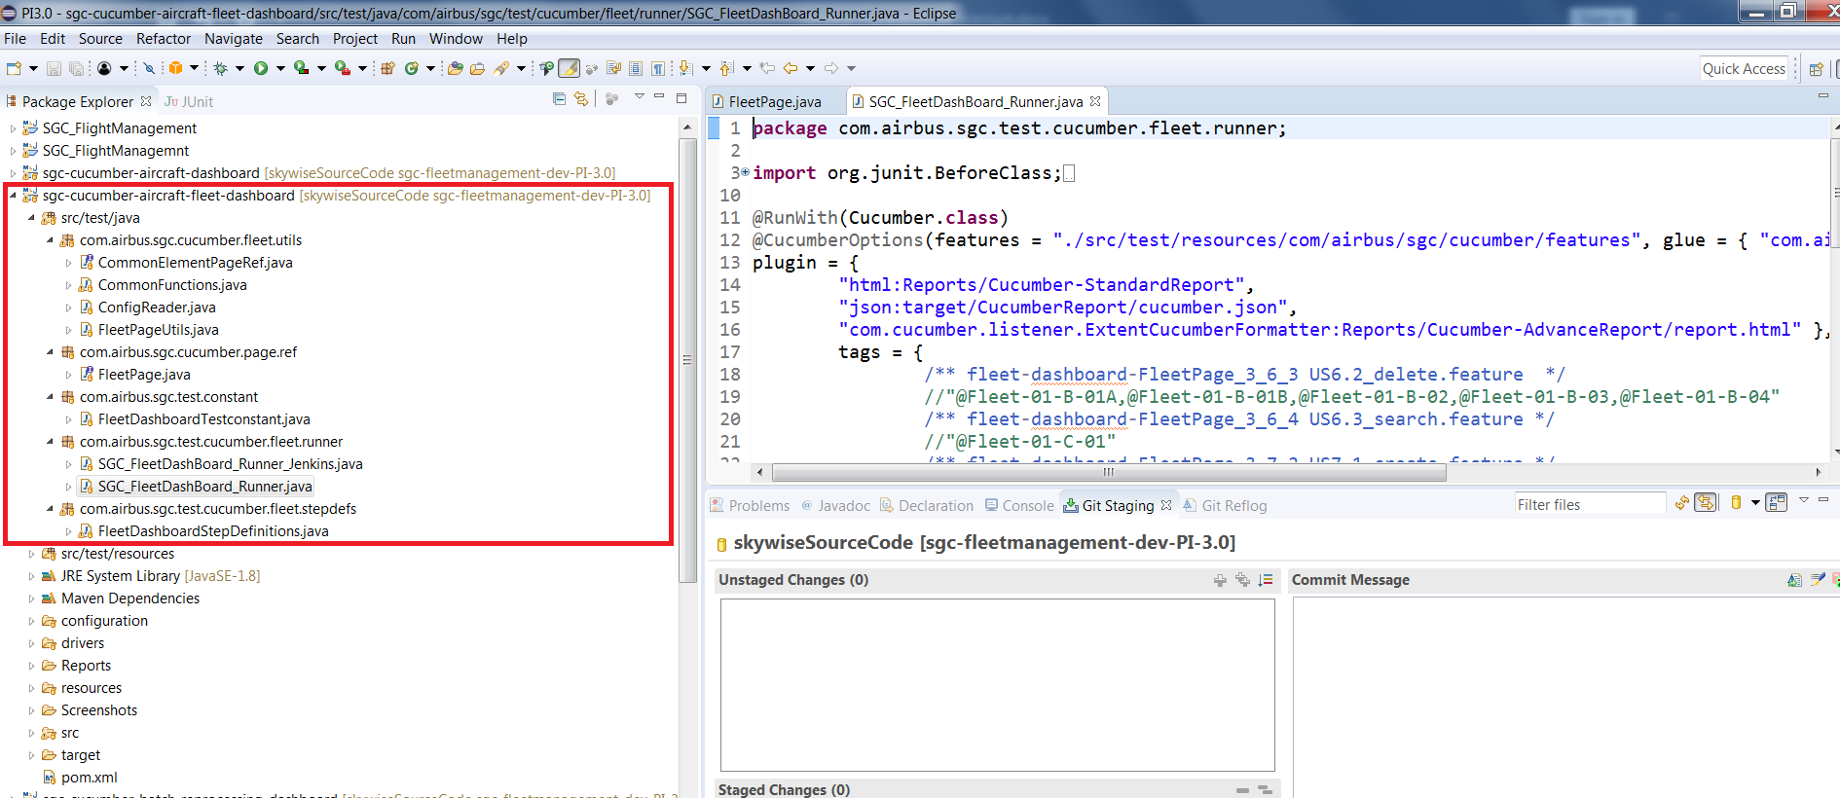

1. Scrrenshot for Feature file

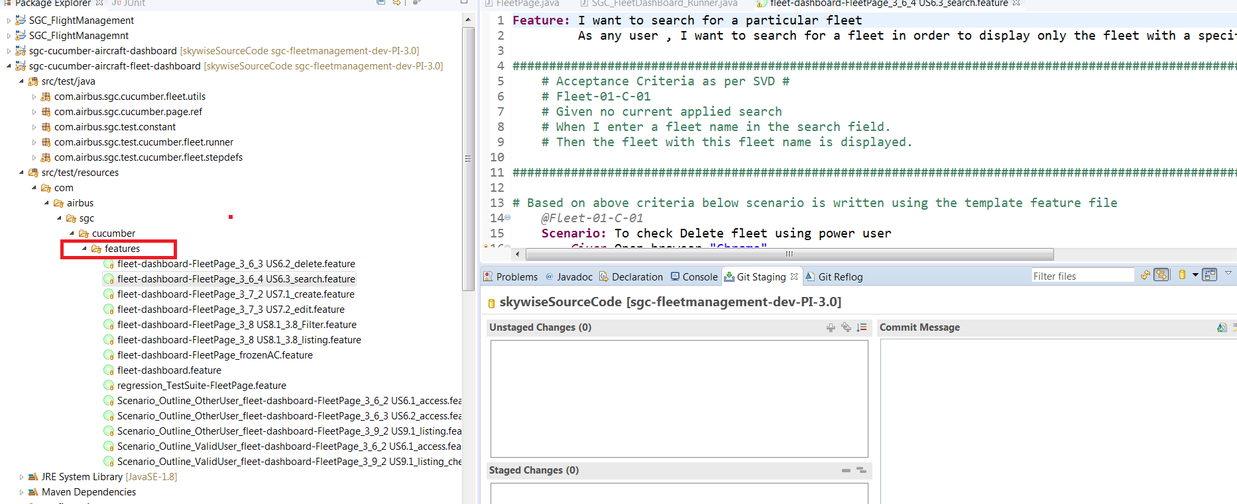

1. Content of feature file.

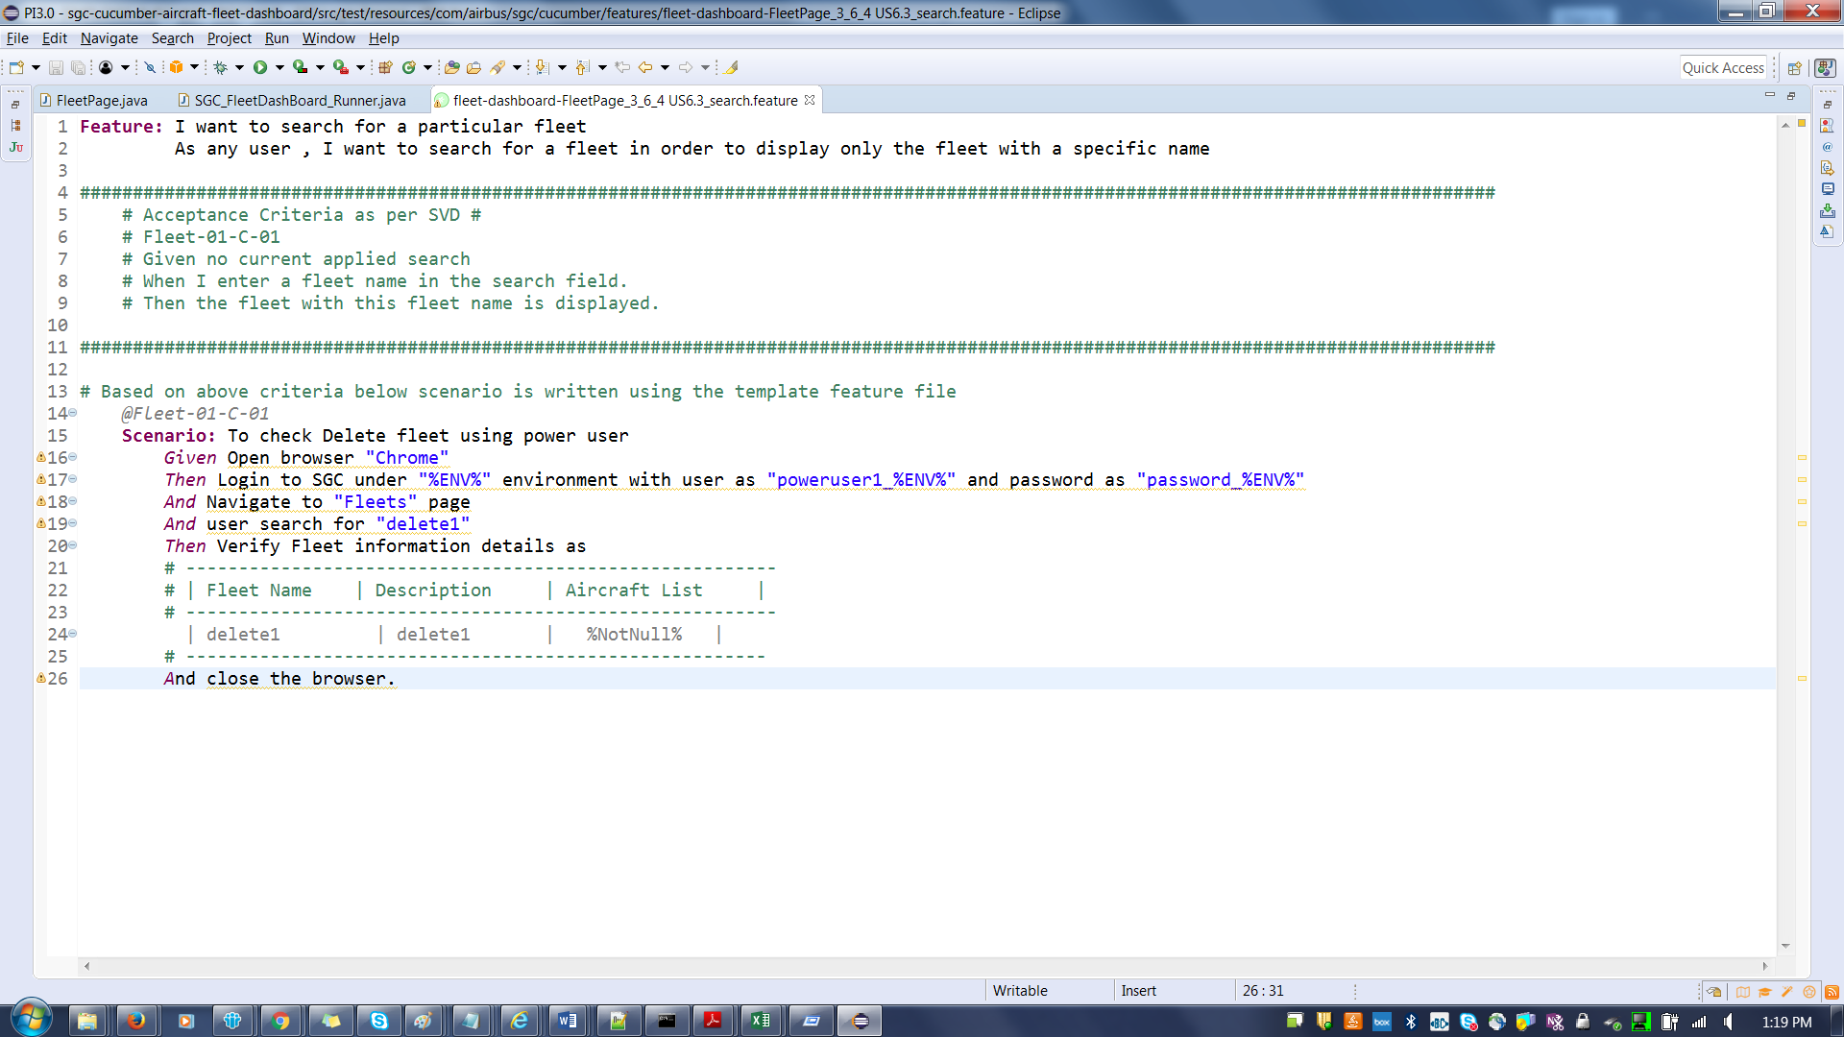

1. Content of Step definition.
2. Content of runner file.